1. Created GitHub Account:

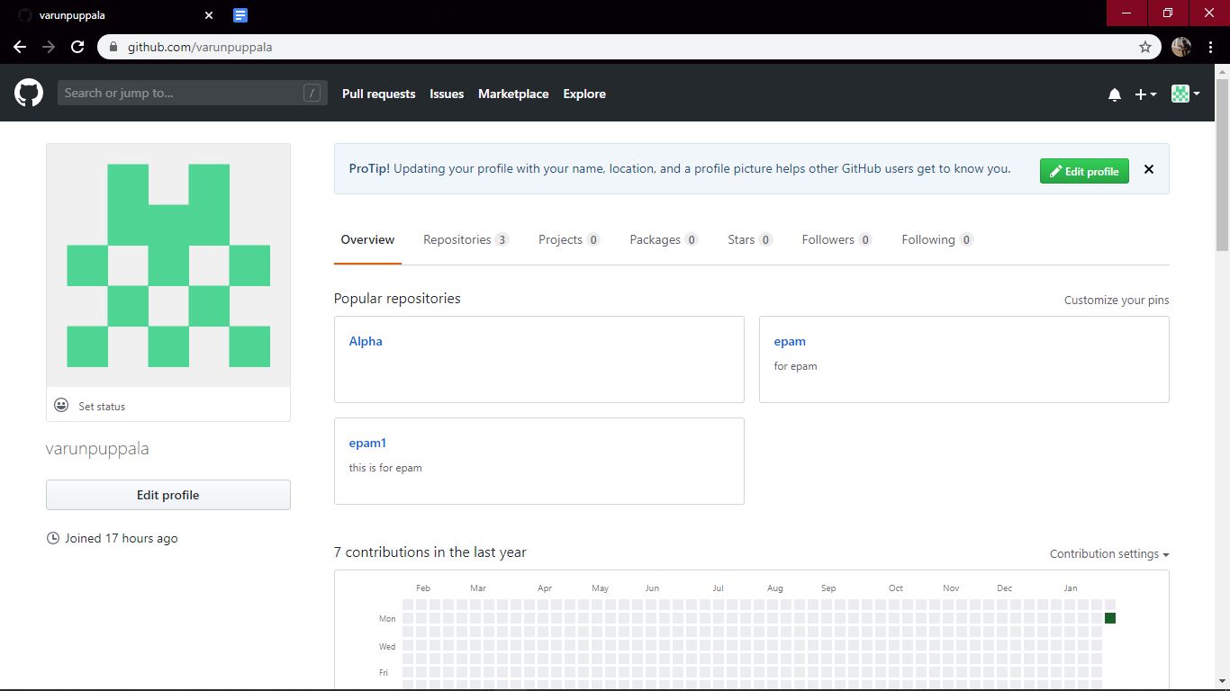

1. Installed Git-SCM in local device/server:

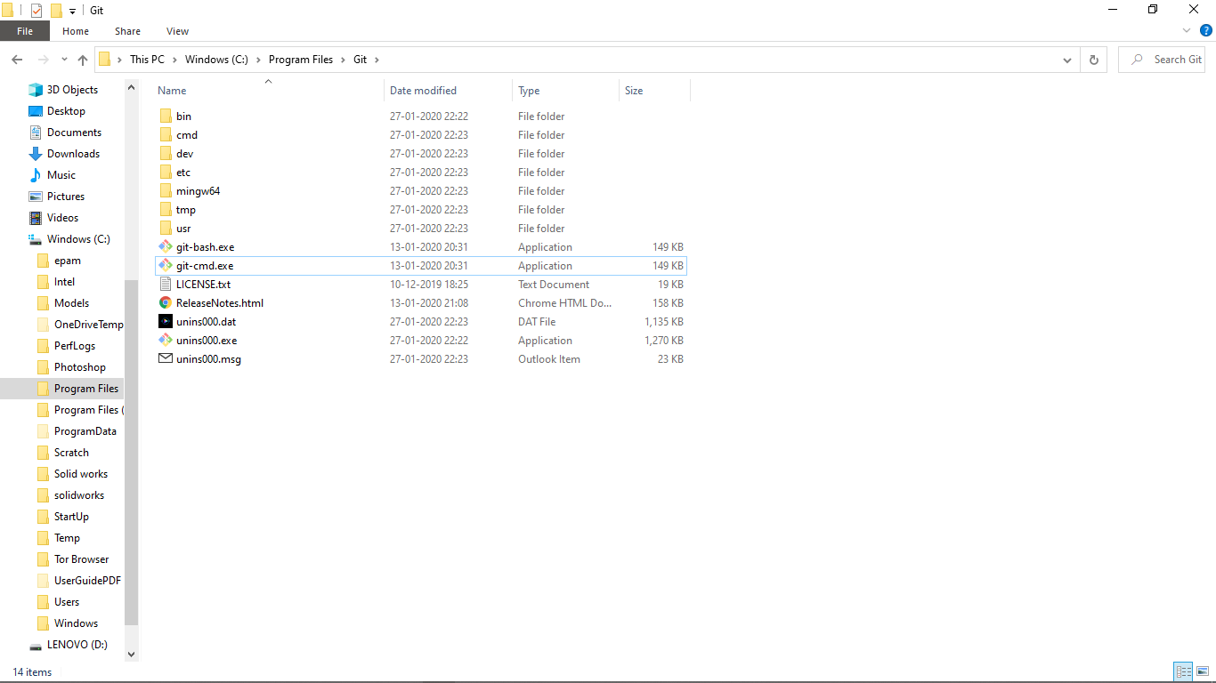

1. Configured Git. Created new directory. Initialized new Git repository, using command line tool of Git 2.2.5 :

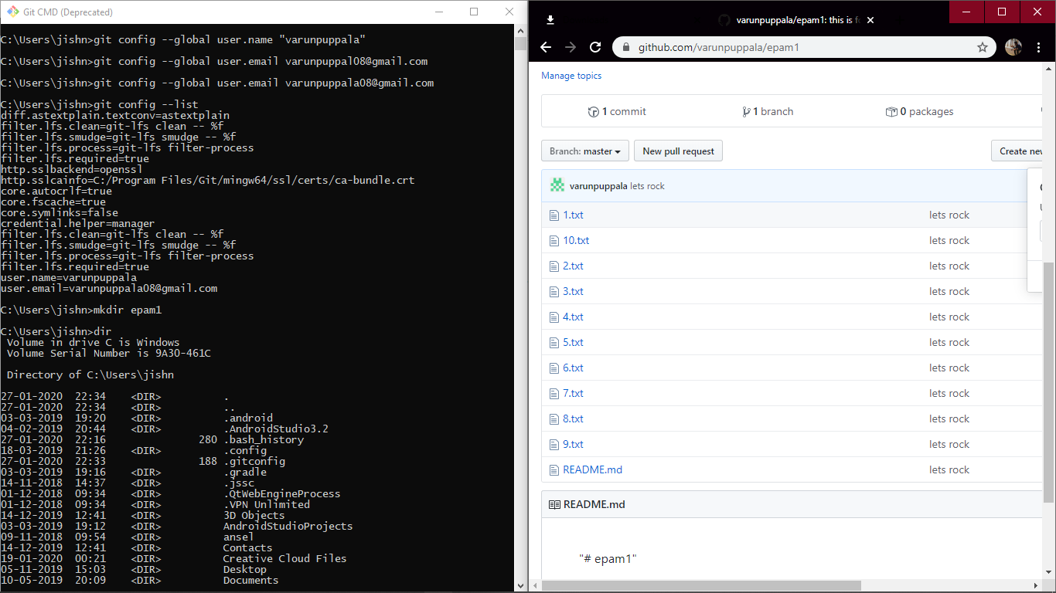

4) Added files into local repository, further into remote server and then pushed the changes from local repository into remote repository.

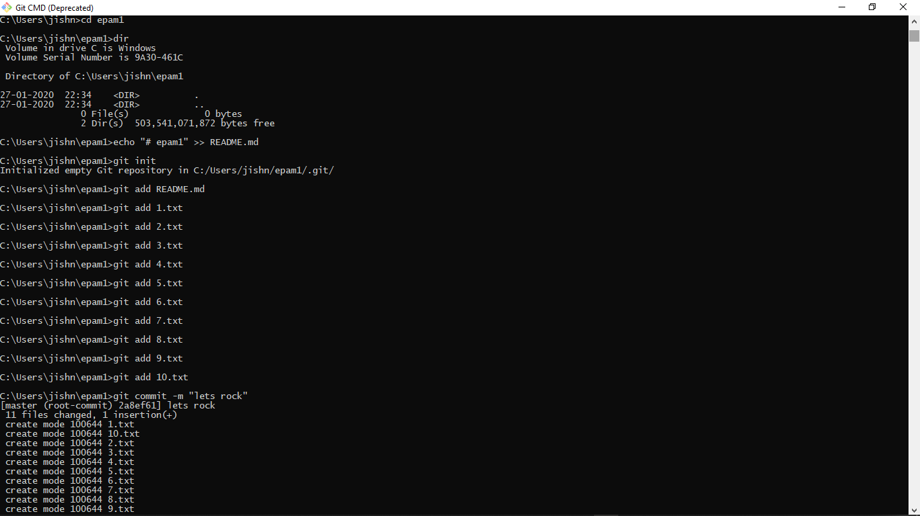

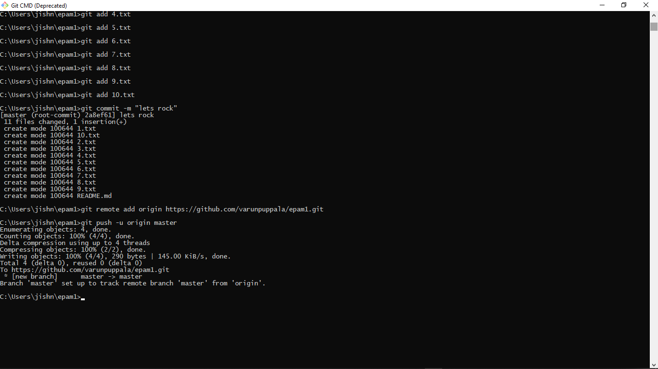

1. Output:

